# The Application of TDengine in Energy Management

Introduction

TDengine is an open source time-series database, which provides an efficient platform for storage, query and analysis of time series big data. So, TDengine is always used to manage energy because the use of energy involved many aspects, such as types of energy(water, power etc.), locations, devices and so on.

In the current industrial system, the energy management platform collects and dynamically several resources in real-time. Secondly, the platform calculates energy savings and costs along several dimensions. What’s more, it also helps with auditing, industry standard benchmarking and reporting to help with energy conservation and management.

Unfortunately, I am not a engineer or a member of TDenginee now. I am a university student who major in Software Engineer in Sichuan University. (That means my future is not sure, but who knows?)

I try to find a suitable scenario which is closed to our daily life and is about energy management. Water and power is very important to our daily life. We must drink water, take a shower, brush our teeth and wash our faces, and we must turn on lights, charge our mobile phones and computers.



Model

In the use of water and power resources, I treat a family or each household as a unit and a company can be devided to many small units. Every unit has its unique id. In our daily life, different devices consume different resources and every unit absolutely has many divices. To

get enough data, I think that it collects the cost of resource through timestamp and the cost of money. These data will deliver to smart meters and I hope that it makes manage energy more easily and we can make predictions to the future.

-SuperTable:

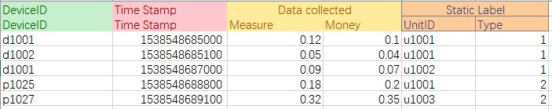

Here you can see that I regard unitID and type as the static label; (It is just an example)

Design and SQL Statements

Create the super table:

**Create table smeter (deviceid char(10), ts timestamp, measure float, money float)**

**Tags(united char(10), type int)**

Create table of different units and types:

**Create table t1 using smeter tags(“u1001”,1)**

**Create table t2 using smeter tags(“u1001”,2)**

**Create table t3 using smeter tags(“u1002”,1)**

Insert data:

**Insert into t1 values(d1001, 153854865000, 0.12, 0.1) (d1002,153854865100, 0.05, 0.04);**

**Insert into t2 values(p1025, 153854868800, 0.18, 0.2);**

**Insert into t3 values(d1001, 153854867000, 0.09,0.07);**

Read data:

**Select deviceid from t1 where money < 0.1;**

**Select sum(measure) from t1 interval(10s);**

**Select * from t2 where measure >0.2 order by ts;**

Query the the most expense of all smart power meters in unit1001:

**Select max(money) from smeters where united = “u1001” and type = 2**

All the above are some basic SQL operations for the smart system. Through TDengine, when we face to tens of millions of data, we also can query information what we want.

Still a long way to go, I hope I can learn more about TDengine, starting with this assignment.